This sample protocol is provided by OCA as an aid for contractors to develop their own corporate COVID-19 safety management plan and protocols. It has been compiled from the generous pooling of resources seeking to develop the highest standard of jobsite measures. Version 2 - 03/27/2020

**Sample Protocol for JOBSITE MEASURES to Protect Against Covid-19**

**HOW THIS PROTOCOL WORKS**

This protocol divides the process for creating a safe workplace into the Four Ps:

**Preparation – Prevention – Protection – Policing**

The first step is **Preparation**. All work sites must be prepared to meet the new

reality of working during a pandemic. Layouts must be adjusted. Shift schedules

and crew arrangements must be modified to allow all workers to follow Health and Safety guidelines provided by Health Canada for social distancing and health hygiene while continuing to work. New cleaning processes and procedures must be put in place and enforced.

The next step is **Prevention**. Anything that increases a risk to workers on site must

be prevented from getting onto the site. This step requires strict screening and

monitoring of all individuals coming onto the site.

The third step is **Protection**. Every resource necessary to ensure the safety of all

workers on site must be present and used by all workers. This includes appropriate PPE, handwashing, and other resources to allow all workers to meet Public Health guidelines while at work.

The final step is **Policing**. Without adequate enforcement the best planned safety

measures are ineffective. All employers should have within their health and safety policy statement a section that addresses the requirement to identify all hazards or potential hazards within the workplace. The Covid-19 is a **new hazard** in the workplace and must be identified on all your hazard risk assessments with controls measures put in place.  All employers, managers, supervisors and employees must be engaged in the process of identifying and correcting unsafe workplace practices. Below are suggested ways to implement control measures on your Hazard Risk Assessments for Covid-19.

The details of this protocol’s requirements at each step are set out further below.

**STEP 1: PREPARATION**

1. Schedule Adjustments
2. Work Process Assessments
3. Social Distancing On-Site Rules

**STEP 2: PREVENTION**

1. Restricted Site Access
2. Daily Health Review
3. Encouragement of Self-Reporting – Access to Income Replacement
4. Rules Regarding Off Site Conduct

**STEP 3: PROTECTION**

1. Regular Cleaning of Equipment and Surfaces
2. Use of Protective Eyewear, Gloves and Masks
3. Disinfectants and Sanitizers
4. Toilet Facilities
5. Reinforcement of Basic Hygiene Rules

**STEP 4: POLICING**

1. Enforcement

**STEP 1 PREPARATION**

Maintaining a safe distance from all other individuals is of high importance.

Changes to the way the workplace is set up to make it possible for workers to work at a safe distance from each other as much as possible will be necessary.

* 1. **SCHEDULE ADJUSTMENTS**

Fewer people on site at the same time will mean fewer opportunities for too-close proximity. All worksites must review their staffing policies to reduce the number of workers on site at any given time to levels which will enable effective social distancing.

Preparing the Job site by adjusting schedules may mean:

* Reducing the number of crews on site at any one time;
* Staggered work start and work end times to avoid gathering at entry and exit ways and other pinch points;
* Staggered break and lunch times to avoid gatherings; and
* Building in time to appropriately sanitize worksites and materials into the

daily schedule

**1.2 WORK PROCESS ADJUSTMENTS**

**We ask our trade partners to examine their work assignments** on-site to ensure your workers are planning their work together with consideration as to safe distancing of 2 metres apart and interaction.

**Please collaborate with our site project management** to come up with a work plan or other accommodation options as to work situations where multiple trades are working in close proximity to one another.

Such a work plan may include:

* Alternatives ways of completing the task;
* Additional PPE and sanitation measures to be used while completing the task.

Preparing the job site by adjusting work processes may mean:

* Imposing limits on the total number of workers allowed within an area or in a hoist to enable social distancing,
* Rearrangement of the site to eliminate ‘pinch points’ such as narrow entry and exit ways, cramped site trailers, narrow pathways;
* Elimination of unnecessary areas of gatherings such as food trucks or indoor cafeterias; and
  1. **WORK RULE ADJUSTMENTS**

New rules about on-site behaviour will mean individual employees aren’t solely

responsible for making sure social distancing is practiced by all workers.

Rules must be implemented, communicated, and enforced that all workers shall

remain a minimum of two 2 metres apart from each other. Unnecessary close

contact shall be prohibited.

Where on-site meetings are necessary to share information, worksites must limit

the number of participants meeting to numbers that locations allow for minimal required distancing. This includes at breaks and lunch hours.

**STEP 2: PREVENTION**

Once the site is set up and good practices and rules are in place, steps must be

taken to ensure that to the maximum extent possible, no contagious persons or

objects make their way into the worksite.

* 1. **RESTRICT SITE ACCESS (See Questionnaire – Appendix 1)**

All employees, subcontractors, union site representatives and visitors to the

project must be required to complete a Coronavirus (COVID-19) Questionnaire before entering the worksite.

The questionnaire should be comprised of these three main questions.

**1. Have you travelled outside Canada in the last 14 days**?

Yes _____ No _______

If Yes - Date of Return?_________ (must be 14 days minimum to stay on site)

2. **Do you currently have any symptoms consistent with COVID-19, including the**

**following symptoms**: fever, coughing or difficulty breathing?

Yes _____ No _______

**3. Have you been exposed to a person who has a confirmed or probable case of the**

**COVID-19 infection?**

Yes _____ No _______

Anyone who answers “yes” to any of the three questions must not be permitted

access to the worksite until that person has completed a 14-day self-isolation period with no symptoms manifesting.

All approved for access to the project should be collected into a database for ongoing project communication.

* 1. **DAILY HEALTH REVIEW**

Subcontractor Responsibility -All trades are expected to monitor their own workforce and ensure they are fit for duty. This will require a morning review of the health of each worker under each foreman’s supervision. This is to take place during the morning PSA process and will require foremen to assess the health of each worker.

* 1. **ENCOURAGE SELF-REPORTING**

Employees are encouraged to self-monitor and must voluntarily leave the job site if they experience any signs of illness. The symptoms of COVID-19 are shared with many other illnesses including the cold and the flu. Any worker or visitor who begins experiencing symptoms of cold or flu while on site should voluntarily leave after reporting to their supervisor.

No reprisals will be taken against any employee for doing so and doctor’s notes will not be required from an employee who leaves because they experience symptoms.

Employees with heightened fear of contracting coronavirus will be offered a layoff

and a ROE will be issued to enable that employee to access income

replacement during the layoff.

In addition, all workers experiencing symptoms will be advised to complete the self-assessment on the Ontario COVID website and follow instruction there, or call

telehealth (1-866-797-0000), their local public health unit or their family physician.

* 1. **Mandatory Public Health Reporting**

Public Health is the leading authority for all issues related to COVID-19 and only

they can provide detailed instructions to employees and employers.

Occupational illnesses among employees on site including COVID-19 will be

reported:

1. to the Ministry of Labour, Training and Skills Development (in writing) within four (4) days;
2. to the joint health and safety representative; and
3. to WSIB

If any employee is confirmed to have tested positive for COVID-19, the jobsite to

which the employee reported will be shut down immediately until a safety and risk assessment is completed. That assessment shall be completed in conjunction with the Ministry of Labour, Training and Skills Development. Work crews who have been in contact with the infected employee will be required to self-isolate away from the workplace for fourteen (14) days, among other measures which at a minimum shall include thorough cleaning and disinfecting of all common surfaces.

Any recommendations of Public Health Officials will be followed. Subject to any recommendations of Public Health Officials, employees who have completed a

fourteen (14) day self-isolation period without experiencing any symptoms consistent with COVID-19 shall be entitled to be recalled

**STEP 3: PROTECTION**

Effective social distancing, site cleaning, PPE, and hygiene practices that ensure the virus is not transmitted through commonly touched objects are important to the protection of all workers.

The following practices must be undertaken to protect workers from cross-contamination.

**3.1 REGULAR CLEANING OF EQUIPMENT AND SURFACES**

All ‘high-touch’ surfaces must be cleaned using soap and water or an alcohol-based rub on EVERY shift.

This includes door-way entrances, door handles, light switches, ladders, elevator

buttons, keyboards, phones and all construction equipment handles, consoles,

controls and seats, subject to any risk to damage to such equipment.

Offices, trailers, containers, workshops and other facilities will be properly cleaned.

The frequency of cleaning each work area and surface will depend on the number

of people who use it, the duration of use, and the presence of any objects which

people might handle with their bare hands.

Materials such as wood, rebar and pipes, temporary structures such as formwork

and braces, and shared tools such as drills, crowbars, and fret saws are rarely

touched with bare hands and require cleaning but do not need to be disinfected.

* 1. **USE OF PROTECTIVE EYEWEAR, GLOVES AND MASKS**

**Safety Eyewear**

If employees are required to wear protective glasses or face shields in the course

of their work, such glasses or face shields shall be for the use of that employee only and shall be clearly identified as such.

PPE must be issued for individual use only.

Products will be made available for cleaning protective glasses or face shields .

**Work Gloves**

Employees are encouraged to wear protective work gloves in the course of their

work, such gloves will be issued to that employee only. Gloves must not be shared

and should be marked with the name of the individual to whom they are issued.

Infection can adhere to gloves. Therefore gloves should be laundered, and clean gloves worn each day. Workers are required to wash their hands with soap and water each time their gloves are removed.

* 1. **DISINFECTANTS AND SANITIZERS**

Wash stations provided on site shall be in easily accessible locations. There shall

be wash stations on every floor of a building. All workers will be required to wash

their hands every time they remove their gloves.

A supply of disinfectants and hand sanitizers will be provided on site for general use and will be replenished as needed.

* 1. **ADDITIONAL MEASURES FOR TOILET FACILITIES**

Soap / paper towel dispensers, hand dryers and hand sanitizing stations on site will be checked frequently and replenished as needed. Place additional temporary soap dispensers in locations where it often runs out, or where fixed dispensers don’t work properly.

Garbage bins will be placed near toilet’s exit doors to encourage people to use a

paper towel to open/close the door. If necessary, set up a separate supply of paper towels near the exit door.

Paper towel dispensers will be placed near high-touch surfaces such as water

coolers, kitchen/break room counters, conference rooms, and other locations with shared high-touch surfaces.

* 1. **REINFORCEMENT OF BASIC HYGIENE RULES FOR ALL WORKERS**

All persons on a jobsite will be directed and reminded to take the following

individual hygiene measures. Notices and recommendations will include:

* **Wash your hands often with soap and water for at least 20 seconds**, especially after using the washroom - **use alcohol-based hand sanitizer** if soap and water are not available;
* **Avoid touching your eyes, nose and mouth** with unwashed hands;
* **When coughing or sneezing: cough or sneeze into a tissue or the bend of your arm,** not your hand, and dispose of any tissues used as soon as possible in a lined waste basket and wash hands afterwards;
* **Avoid hugs and handshakes**;
* **Avoid commonly touched areas** including handrails and public transit poles;
* **Wash your clothes** as soon as you get home and shower;
* **Take outside shoes off before entering your home and do not allow them in your house;** and
* **Notify your supervisor** immediately if you feel sick

**STEP 4 – POLICING**

* 1. **ENFORCEMENT**

The final step is **Policing**. Without adequate enforcement the best planned safety

measures are ineffective. All employers should have within their health and safety policy statement a section that addresses the requirement to identify all hazards or potential hazards within the workplace. The Covid-19 is a **new hazard** in the workplace and must be identified on all your hazard risk assessments with controls measures put in place.  All employers, managers, supervisors and employees must be engaged in the process of identifying and correcting unsafe workplace practices.

All employers shall make clear to employees the process for reporting concerns or

violations in regard to this policy or COVID-19 risks at their workplace. No reprisal

shall be taken against any individual for reporting concerns with respect to this

policy or COVID-19 protections.

**Appendix 1 - Coronavirus (COVID-19) Preventative Measures**

**Questionnaire to be completed by all personnel entering the site**

The Public Health Agency of Canada (PHAC) currently assesses the public health hazard associated with COVID-19 is low for Canada. However, _________ wishes to take preventative measures to ensure the health and safety of all its employees, visitors and those around them, as well as its working environment.

Please complete this short questionnaire to ensure your presence does not pose a risk to the project and to return the completed form to the Site Superintendent.

All employees assigned to this site must complete this form and submit to ____________ prior to entering the site.

**Personal information** -

First and last name: ____________________________

Email: ____________________________

Cell Phone: ____________________________

Employer: ____________________________

1. **Have you travelled outside Canada since March 12th**?

Yes _____ No _______

If Yes - Date of Return?_________ (must be 14 days min to stay on site)

1. **Do you currently have the following symptoms**: fever, coughing or difficulty breathing?

Yes _____ No _______

#### Have you been exposed to a person who has a confirmed or probable case of the COVID-19 infection?

Yes _____ No _______

**Declaration:**

#### I hereby confirm that the information provided herein is accurate, correct and complete and that the responses submitted within this form are genuine.

#### I undertake to inform ________________in writing of any changes to the information already provided and to update the information on this form whenever requested to do so by.

#### Signature Date

**WEB BASED DECLARATION OPTION INSTEAD OF PAPER**

Pomerleau has set up the declaration form online using SURVEY MONKEY and all workers at site reception have to complete it. Check this out as this may save you the headaches of paper forms if you can get visitors and workers to use their smart phone to self-complete the online questionnaire.

The Pomerleau questionnaire is at <https://fr.research.net/r/POMERLEAU_COVID19?lang=en_CA>  and looks like this:

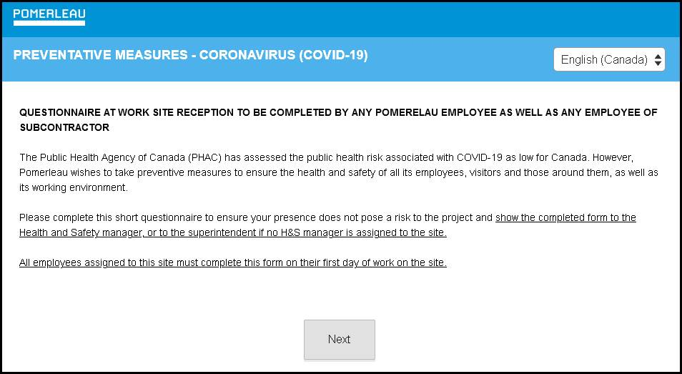

The **Survey Monkey website  can be accessed at this** [**LINK**](https://www.research.net/pricing/?ut_source=research_net&ut_source3=hero&ut_ctatext=Get%20started%20now)**.**

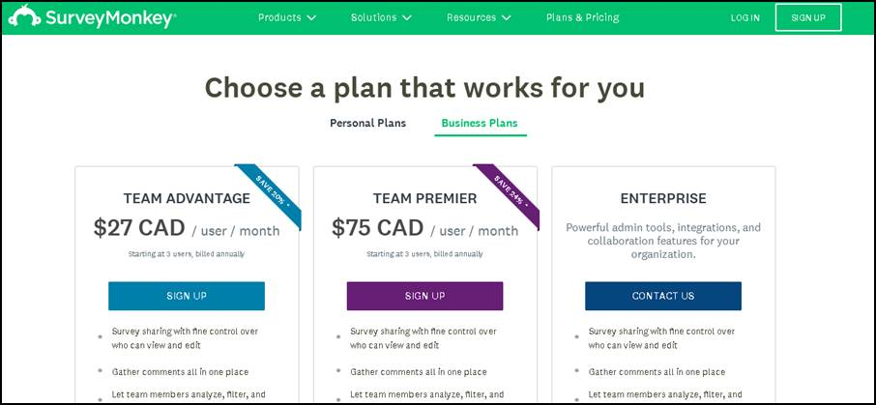

Another option is using Microsoft Forms. Waterdon Construction advises they created an on-line form very quickly.