Meet Our Trainers Who Care About Getting “IT” Right!
Debbie Hicks, BSc
Facilitator

With a comprehensive and varied education background, learning has been at the core of her career. As former President of the Southern Interior Construction Association in BC for 22 years, liaising with the buyers of construction services, architects, engineers and contractors in advocacy and education brings a solid base to her expertise. In addition, her experience as the owner representative for the construction of the new Clubhouse for the Kelowna Yacht Club has provided additional perspective. She has been fortunate to work with the Alberta Construction Association to facilitate industry dialogue on “Optimizing the Flow of Money” and “Non-Standard Contract Clauses and their Costs”. Through these experiences, with a lot of passion and enthusiasm, Debbie is able to bring both knowledge and insight into her work and presentations for the construction industry.
Michael Atkinson, LLB (retired)
Past President Canadian Construction Association (CCA)
Past Secretary Canadian Construction Documents Committee (CCDC)
President, Unitech Construction Management Ltd.

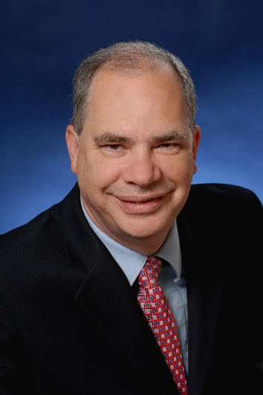
Michael Atkinson was President of the Canadian Construction Association (CCA) from March of 1993 to October of 2017. He joined CCA in 1981. In November 1982, he was appointed Secretary to the Canadian Construction Documents Committee (CCDC), a position he held until 1993.
Michael has emerged as a leading expert in the area of standard construction contracts and practices in Canada. In 2013, he was awarded one of 38 Queen Elizabeth II Diamond Jubilee medals designated for Canadians demonstrating outstanding service in the construction industry in Canada.
Michael served as the Private Sector Vice-Chair of the Municipal Infrastructure Forum established by the Federation of Canadian Municipalities. He was a member of the Federal-Industry Real Property Advisory Council, the Industrial Security Advisory Board, the CORCAN Advisory Board, and a long-time member of the Construction Law Section of the Canadian Bar Association.

Rick Boates, AScT., GSC, LEEDAP, Lean Green Belt
Unitech Construction Management Ltd. | President

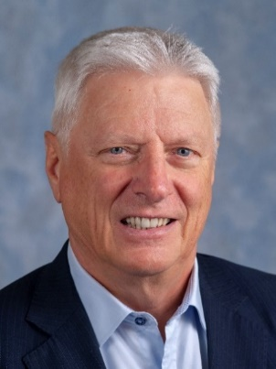
Rick’s career in the construction industry spans 49 years including 14 years in design consulting, 2 years as a Building Inspector and 33 years as founder and President of one of BC’s leading Construction Management firms. Rick served on the Board of ICBA, the Independent Contractors and Businesses Association for 8 years. Rick also served on the Board of Merit Canada for 8 years and is now dedicating his board efforts to the Delta Hospital and Community Health Foundation.
Rick has guided Unitech through the successful completion of nearly $1.5 billion worth commercial, institutional, recreational, hospitality, First Nations, Health and even civil and industrial projects throughout BC. All of these projects been implemented via Construction Manager as Agent via old CCA 5 or CCDC 5A contracts on behalf of many repeat public and private clients. He is continuing his passion for collaborative construction with $400 million in CM contracts in progress and is leveraging Unitech collaborative approach on promotion of IPD and Lean Construction on current and upcoming projects.

Elisa Brandts, Architect AIBC, Architect AAA, OAA, NSAA, FRAIC
Stantec | Managing Senior Principal

Elisa is a Senior Principal and the Business Centre Managing Leader for our buildings group in British Columbia. Her role combines active senior team leadership and financial and studio management with managing significant projects, particularly of large-scale alternate delivery scope, IPD and those integrating Lean process.

Elisa’s accomplishments include Eric Hamber Secondary School Replacement Project, Vancouver; Camosun College Alex and Jo Campbell School of Health Sciences, Victoria; Canalta Centre, (2015)*, Medicine Hat, Alberta; Sault Ste. Marie Event Centre, (2006)*, Sault Ste Marie, Ontario; Youngstown Convocation Center, (2005)*, Youngstown, OH, USA; Rideau Carleton Raceway, (2000)*, Ottawa.
* denotes projects completed with other firms
De

Jim Clement, GSC
Graham Construction | Operations Manager

A seasoned construction professional with over 40 years of experience — the vast majority of which has been spent in the Calgary marketplace — Jim has the ability to think outside the box and finds creative solutions to complex design issues. Jim recognizes and understands the importance of proper cost and schedule control, as well as the interaction required between the owners, consultants, and construction management personnel.
Jim has been the President of both the Calgary Construction Association and the General Contractors Association, has been awarded Person of the Year by the Calgary Construction Association for his industry contributions, and has presented on design collaboration and ensuring optimum value and services for project owners. Jim adds value to his projects through his effective management of project constructability, and an understanding of the full project delivery. As a natural leader, he provides clients with the optimum balance between cost, schedule, quality, performance and project lifecycle.
Jim has worked on a wide array of construction projects including: commercial office buildings, residential towers, retail developments, parks and civil work, industrial facilities, and a variety of other project styles and types.
Terry Danelley, FRAIC, MAA
LM Architectural Group | Senior Advisor

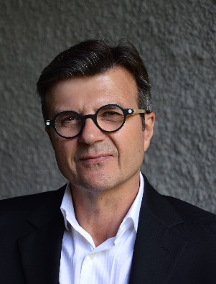
Terry has over 30 years of experience with LM Architectural Group including 20 years as a principal, directing the firm’s educational facilities team in programming, planning and design of public, private and First Nations educational facilities, including daycare facilities, K-12 schools and post-secondary projects.
Terry’s experience includes a wide range of different building typologies and scales covering the institutional, educational, residential, office/commercial, and industrial market sectors. He has extensive experience in the Design-Bid-Build, Design-Build, Construction Management and Integrated Project Team delivery methods.

Terry now acts as a special advisor to the partnership; serving LM’s education group and undertaking design and planning assignments related to that sector of the firm.

Bob Hildenbrandt, P.Eng., LEED® AP, GSC (retired)

A dedicated construction professional with over 40 years of experience in the Alberta marketplace. Bob has recently retired from Graham Construction where he was Vice-President, Prairies. He developed and led a regional team of construction groups in Western Canada, focused on performance and client satisfaction.
His prior experience includes leadership roles at Ledcor and PCL with an extensive list of major projects as project manager and executive-in-charge. He was also part of a significant team executing major projects in Alberta’s Oil and Gas market by developing strategic initiatives. Bob has an excellent reputation in building teams, motivating staff, and overcoming challenges in the delivery of construction projects. He has developed strong personal relationships throughout all facets of the industry including Clients, Consultants and Trades.
Bob is a past Chair of the Calgary Construction Association and Alberta Construction Association, and was on the Board and Executive of the Canadian Construction Association, as well as chair of national construction industry organizations focused on BIM and Lean Construction.
Mark Scharf, BA Hons, MHA
Calgary Health Region and University of Calgary (retired) | Senior Director

Mark recently retired from the University of Calgary where he was responsible for the delivery of capital projects across the organization. The annual workload entailed approximately 400 capital and renovation projects per year with an annual project spend of approximately $150M. During his 12- year tenure as Director, the Project Management Office delivered 9 new buildings including multiple teaching and applied research buildings, major infrastructure renewals, new residence halls and a new main library. Mark was actively engaged with procuring design and construction teams and negotiating and overseeing a wide variety of contracts including Design Build, Construction Management at Risk, Lump Sum and performance-based engagements.
Mark brings 30 plus years of public sector experience with both post-secondary and health organizations including the Calgary Health Region and Age Care Senior Communities. Mark takes pride in building strong teams, mentoring the next generation of project professionals and engaging diverse stakeholders in achieving outstanding results.

Keith Robinson FCSC, RSW, LEED® AP | DIALOG |Associate (retired)| Research and Development, Specifications

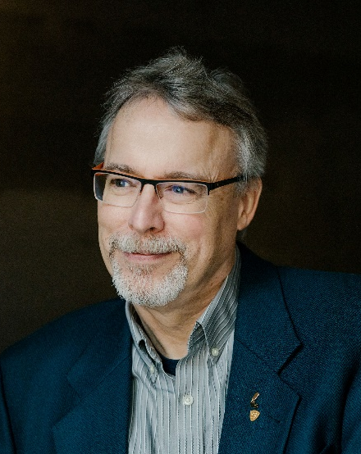
Keith Robinson graduated from the Northern Alberta Institute of Technology (NAIT) as an architectural technologist in 1980, and has worked as a specifications writer since 1981. Keith worked for DIALOG; a multidiscipline architectural and engineering company, since December 1996 until his retirement in early 2023.
Keith’s primary role in the last 25 years of his career was writing construction documentation (specifications and contracts) for technically complex, unique and innovative projects. His project experience ranged from hospital and university campuses, high-rise construction, bridge and tunnel infrastructure, and commercial/retail developments. His duties at DIALOG included maintaining the in-house master specification and technical library, and addressing various challenges associated with identifying building materials to address environmentally sustainable construction work results. Keith prepared contract documents for all forms of construction delivery including standard stipulated price agreements, construction management and design build agreements, and public/private partnerships.
Craig Shirra, B.Tech, GSC, PSQ, LEEDGA
UBC Properties Trust | Director, Development

Craig is currently the Director of Development at UBC Properties Trust, where he acts as the owner’s project managers for all new capital projects at the University of British Columbia Okanagan campus and Kelowna region.
Craig stated his construction career as a steel stud and drywall tradesman working on some of Vancouver’s most significant projects pre-Olympics like the Richmond oval, BC place renovation and Queen Elizabeth Theatre renovation. Craig then joined Task Construction Management, a boutique CM firm managing projects such as the Vernon Library and South Surrey Rec Center. In 2012 Craig joined Bird Construction where he was part of the team that delivered the new UBC Student Union Building, Kelowna RCMP and the Indian Residential School History and Dialogue Centre @ UBC Vancouver.
Craig holds a degree in Construction Management and Diploma of Technology as a graduate of the Architectural Building Engineering Technologies program, both at BCIT.
Craig is a LEED Green Associate, A registered Professional Quantity Surveyor (PQS) and has earned his Gold Seal in project management.
Craig is currently leading exciting projects such as the UBCO Interdisciplinary Collaboration & Innovation (ICI) Building, which is a 150,000 square foot research facility, as well as the new UBC Downtown Kelowna Campus.
Brian Soutar, P.Eng., PQS
Alberta Infrastructure |Executive Director of Project Services (retired) | Advisor

Brian Soutar is a professional engineer and professional quantity surveyor with over 40 years of project management, procurement, design, contract management, estimating and quantity surveying experience. He has worked on commercial, institutional, industrial, mining, transportation, water development and multi-family residential projects in Canada, the US, the UK and Africa. Half of his career has been in the private sector, where he has worked for construction companies in project manager, estimator and construction superintendent roles; for design firms in project manager and branch manager roles; and for developers in project manager roles. In the public sector he has held cost manager, project manager, director of major capital projects, and executive director positions. He led four portfolios for Alberta Infrastructure: procurement, the Project Management Office, cost management, and capital planning. Brian believes passionately in collaboration and has served on many multi-sector teams, including as chair of the Institute for BIM in Canada, and the Canadian Construction Document Committee’s task force to create the standard contract for Integrated Project Delivery.
Amy Spark
Bird Construction |Team Lead, Proposals & Marketing – Buildings West & Major Infrastructure

My favorite quote " the proof is in the pudding"
When it comes to pursuit and marketing, the only way to be successful is with a strong process and a unified team response which is also adaptable and scalable to the opportunity.
Amy is a strong pursuit and marketing professional with over 12 years of experience supporting various industries including pipeline, heavy civil, highway maintenance and construction, industrial, healthcare, major infrastructure, and utilities. Amy possesses extensive experience in the management of small and large-scale proposals. She recognizes the industry shift to create customized content in a competitive market in addition to the need to make proposals and marketing a collaborative effort.
Amy is passionate about learning and teaching others in our industry. In the last four years, Amy has graduated from Digital Publishing and Graphic Design in addition to other certifications related to proposal and market management. Currently, Amy facilitates technical writing and grammar workshops aimed at empowering others to gain confidence in their technical writing.

Brad Stevenson, CPA, CGA, B.Tech, PMP
Unitech Construction Management Ltd. | Chief Operating Officer

President, Unitech Construction Management Ltd.

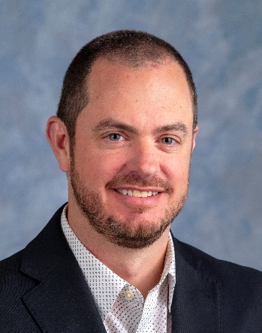
Brad Stevenson is Unitech Construction Management’s Chief Operating Officer. He has been with Unitech for 15 years in a number of different roles including operations, finance, human resources, safety, business development and information technology. Brad has the overall responsibility for integrating all Unitech’s Construction Management’s divisions into one cohesive unit. He has been responsible for integrating Unitech’s systems, processes and procedures, with a focus on team collaboration, into how Unitech does business day to day. He monitors and assists all personnel to ensure everyone in the company is living our core values of being client goal driven, collaborative, concise, firm, fair and fun through our collaborative construction proven process.

Walter Strachan RSW, PQS (F), CSC (F) (retired)

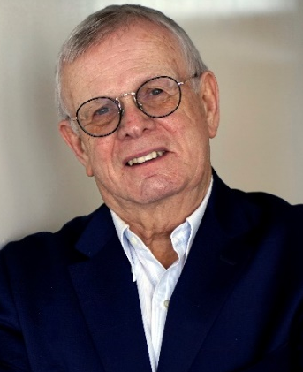
Walter has extensive experience earned through over 40 years in the consulting engineering industry with CBCL Limited. During his career he has served as department manager, project manager, corporate quality manager (ISO 9001), corporate risk manager), principal, director, and Chair of the Board at a major Atlantic Canada based engineering and environmental services company.
Upon retirement from CBCL Limited, Walter opened Act 3 Advisory Services, to continue a life-long obsession with all things related to project delivery in the design and construction industry.
Walter’s design and construction interest center around standard practices, project delivery methods, cost planning and control, risk management, and dispute resolution. Those interests resulted in tenures as Chair, Canadian Design Build Institute (CDBI); President, Canadian Institute of Quantity Surveyors (CIQS); Chair, Canadian Construction Documents Committee (CCDC); and Board Member, Canadian Construction Association (CCA). He has also served on several significant Task Teams including MasterFormat; CSC/CSI Uniform Drawing Systems; and the Integrated Delivery (IPD) Task Team.
Walter is the 2021 recipient of the Nova Scotia Consulting Engineers (CENS) Distinguished Service Award.

Roy Timms, P.Eng. GSC (retired)

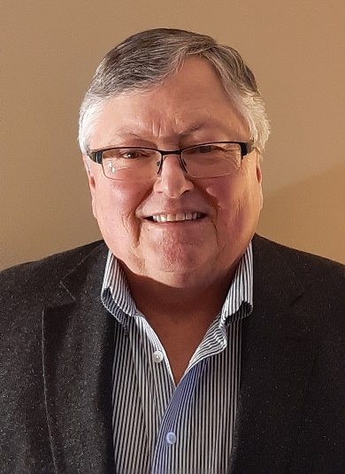
Roy’s career in design build construction started about 50 years ago as a student construction labourer and then a superintendent on a small design build renovation project. Roy is a Professional Engineer who owned a design build company from 1974 to 2019, and a Professional Engineering company for over 30 years.
Roy has served on the Ontario Building Code Commission, is a Past President of the Ontario General Contractors Association, past Chairperson of the Canadian Design Build Institute, the Niagara Regional Chamber of Commerce, and the Niagara Industrial Association, as well as other organizations.
Currently Roy acts as an owner’s agent and a strategic advisor to design build contractors. Roy has experience in private sector industrial, commercial, and retail projects plus municipal work as an owner’s agent and a design builder. These projects have ranged from small to $32,000,000.
Roy has received many honours, including a Life Membership from the Ontario General Contractors Association, and a Niagara Engineering Award of Merit.

Art Winslow C.E.T.(Arch), GSC
Colliers Project Leaders | National IPD Director

As a Canadian Lean and IPD pioneer, Art has consulted with a variety of Canadian and Provincial Governments including several Infrastructure and NGOs and present at many Industries related industry workshops across North America.

Art is the 2018 recipient of General Contractor of the Year for his ongoing efforts to improve the Construction industry in Canada. He is a founding board member of the Lean Construction Institute (Canada), sits on several lean organizations including the CCDC task force who created the CCDC 30 IPD Agreement and is among the first to be certified to instruct of LCI/AGC lean construction education in Canada.

Having managed large scale, multi-phased construction projects, Art is highly experienced in coordinating and facilitating high performance teams. His lean IPD journey combines his existing construction industry knowledge with his acquired Lean and IPD skills. Since 2010, Art has been involved with many lean and IPD projects across North America.

Elizabeth Zhu, BSc
Fraser Health Authority | Procurement Manager

As the three-time recipient of the BCCA Best of Public Procurement Award, we are reminded of the responsibility that comes with it……..to continue to work with industry best practices and maintain a fair, open and transparent procurement process.”

As procurement manager of Fraser Health for 15 years, Elizabeth Zhu has built a procurement team specialized in public construction procurement. The ten-person team manages facility maintenance and construction projects across four health authorities in the BC lower mainland.

Elizabeth is also an acting procurement advisor to multiple BC hospital redevelopment projects. She has a thorough understanding of federal and provincial public procurement policies, as well as various type of construction contracts.

Ms. Zhu is an active member of the BC Public Construction Council. Her procurement team is well known for being the two-time recipient of the 2017 and 2022 BCCA Best of Public Owner awards.

